ADJECTIVES
REMEMBER: Small – smaller than – the smallest
Beautiful – more beautiful – the most beautiful

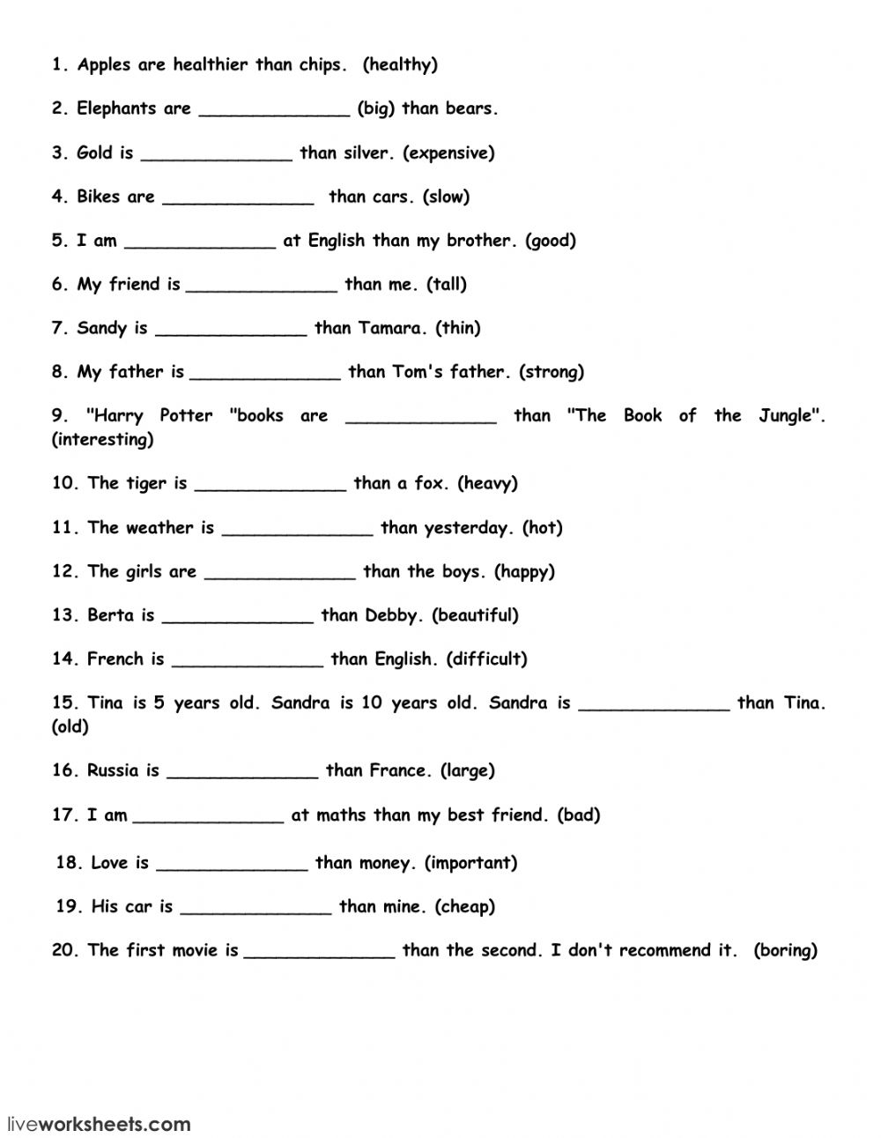
COPY ON A PIECE OF PAPER ☺

