What time is it?

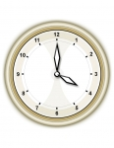
  1. | What time is it?
  1. | a. It's four o'clock. | b. It's quarter to four.
  1. | c. It's quarter past four. | d. It's half past four.

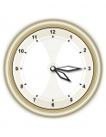
  2. | What time is it?
  2. | a. It'squarter past four. | b. It's quarter to four.
  2. | c. It's half past four. | d. It's four o'clock.

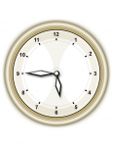
  3. | What time is it?
  3. | a. It's half past four. | b. It's quarter to six.
  3. | c. It's quarter to four. | d. It's half past six.

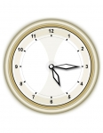
  4. | What time is it?
  4. | a. It's five o'clock. | b. It's quarter past five.
  4. | c. It's half past five. | d. It's quarter to five.

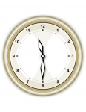
  5. | What time is it?
  5. | a. It's half past ten. | b. It's quarter past eleven.
  5. | c. It's half past eleven. | d. It's quarter to eleven.

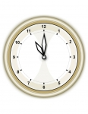
  6. | What time is it?
  6. | a. It's ten o'clock. | b. It's nine o'clock.
  6. | c. It's eleven o'clock. | d. It's five o'clock.

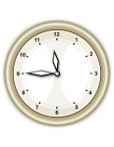
  7. | What time is it?
  7. | a. It's twelve o'clock. | b. It's half past twelve.
  7. | c. It's quarter to twelve. | d. It's quarter past twelve.

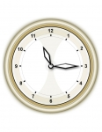
  8. | What time is it?
  8. | a. It's quarter past eleven. | b. It's half past eleven.
  8. | c. It's quarter to eleven. | d. It's half past ten.

