**???**

**Where are they?**

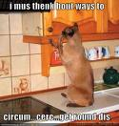 The cat is in the ____________

The cat is _____________________ 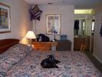

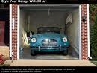 The car _______________________

___________________________  