Score



6

Name: Subject: English Date: Sheet: Reading comprehension

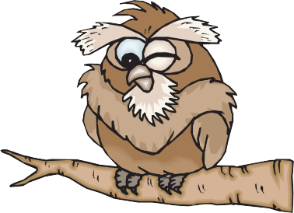

# My name is Otis. I am an owl. Have you heard an owl hoot before? I have a big face and large eyes. I have strong legs and sharp claws called talons. I have big wings and soft feathers. I sleep during the day and hunt for food at night. I like to catch rats and mice. I can see and hear things that are very far away. I have special feathers that allow me to fly without making a sound.

Did you know that a baby owl is called an owlet? My home is in a nest in a tree. Where do you live?

Answer the questions below by putting a circle around the correct letter.

1. What is Otis?
2. an owl
3. an eagle **c** a sparrow **d** a robin
4. What are his claws called?
5. toes
6. nails
7. talons
8. fingers
9. What does Otis like to catch?
10. rats and mice
11. fish and chips
12. ham sandwiches
13. pizza
14. What is a baby owl called?
15. a hen
16. an owlet
17. a calf
18. a piglet
19. What does Otis do during the day?
20. he sleeps
21. he cleans his feathers
22. he hunts for food
23. he hoots loudly
24. Can Otis fly?
25. Yes
26. No

© Primary Leap Ltd. 2020 [www.primaryleap.co.uk](http://www.primaryleap.co.uk/) - Primary Resources